Land Claims and Self-Determination

Name
Department, Institution
Course number: Course name
Tutor
Date

Land Claims and Self-Determination
Land matters tend to be an emotive issue in many regions, and the minority groups are the most affected people. In this case, the First Nations, Metis and the Inuit have some differences in their cultures, which could have adverse effects on their living in their regions. There have been issues among the aboriginal people and the First Nations, The Inuit and Metis. The number of First nations was 554,860 in 2003 (Austin, Kunyk, Peternelj-Taylor & Boyd, 2019). On the other hand, the Inuit were formally referred to as Eskimos and form part of the aboriginals living in Northern Canada. The Metis aboriginals are in the lineage of the First Nations and European. They are known to have Scottish, French, and Cree cultures.
Therefore, there is a distinguished social and cultural differences among the aboriginals compared to the First nations. Some Social needs, such as health, income, education, and employment, have been affected by the dispossession of cultural traditions, social imbalances, and discrimination. More so, social services are likely to be affected by income, family, and cultural factors, but there has been difference due to social and economic conditions that deny the aboriginals their rights. As a result, the Inuit have issues in settlement of land because their cultures and population remains a minority, which denies land rights.
The settlement of land is surrounded by politics on the verge to push for self-government and sovereignty as non-Aboriginal populations rise. Most of First Nations, which are part of Aboriginal peoples, are no longer part of independent nations as the authorities kept them in reserves under the supervision of Indian Department superintendents (The Canadian Encyclopedia, 2020). Aboriginal people are allowed to farm just like their neighbors. They also have universal access to funds and legal rights and treaty rights. However, Métis later lost their inherent rights. Supreme Court made a decision on who fits to be called an “Indian,” which encompassed the Métis and Non-Status Indians in April 2016. Unfortunately, Aboriginal people have not felt the implementation and overall objective.
The Inuit and Metis have been vocal on greater self-determination, aiming to have their rights recognized and have a renewed relationship with the authorities. The objective has been to seek how they can work with the authorities on Recognition of Indigenous Rights and Self-Determination that will lead to getting benefits provincial governments (Government of Canada, 2019). Based on this discussion, the Metis culture is likely to differ from those of First Nations and Inuit on most rights. However, both are indigenous groups that face the same challenges in the land issue.
Concept map
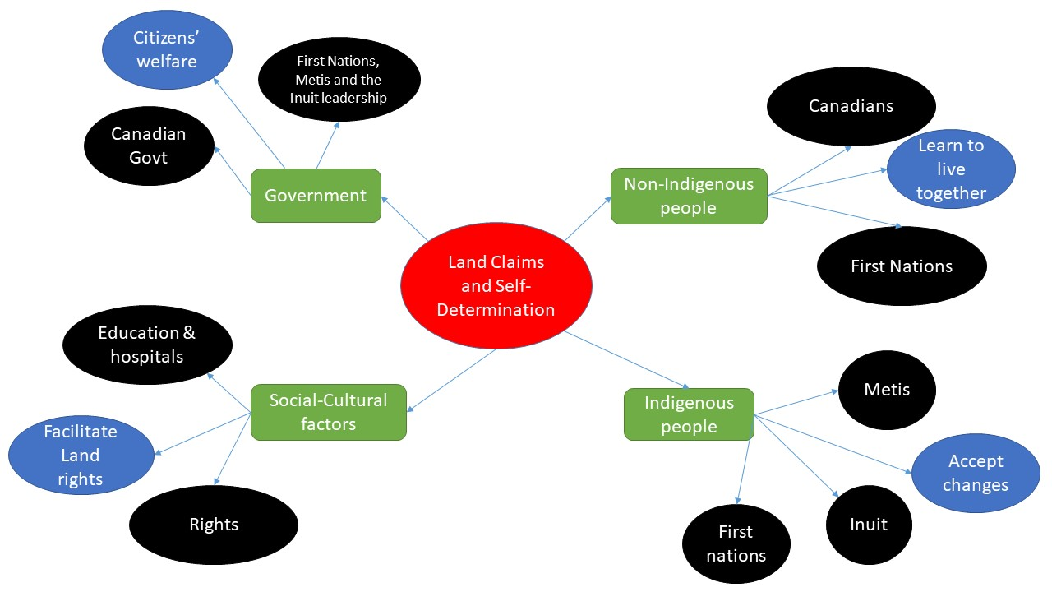

References
Austin, W., Kunyk, D., Peternelj-Taylor, C., & Boyd, M. (2019). Psychiatric & mental health nursing for Canadian practice. Philadelphia: Wolters Kluwer.
Government of Canada. (2019, August 27). Self-government. Retrieved July 4, 2020, from https://www.rcaanc-cirnac.gc.ca/eng/1100100032275/1529354547314
The Canadian Encyclopedia. (2020). Indigenous Peoples and Government Policy in Canada. Retrieved July 4, 2020, from https://www.thecanadianencyclopedia.ca/en/article/aboriginal-people-government- policy

